**PROJECT DEVELOPMENT PHASE**

### PROJECT DEVELOPMENT - DELIVERY OF SPRINT-4

|  |  |
| --- | --- |
| **Team ID** | **PNT2022TMID47589** |
| **Project Name** | Personal Assistance for Seniors who are Self-Reliant |

**SPRINT 4:**

Describing the entire flow through node-RED.

**Work Flow:**

* We have used IoT Watson platform for the creationϖ of IoT device.
* The web application is built using Node-RED forϖ collecting the medicine details from the users.
* We have used the cloudant DB for storing theϖ collected data.
* The web application will send the medicine details toϖ the created IoT device.
* The IoT device on receiving the details, it makes useϖ of TTS to remind the user about the medicine.
* By using TTS (Text to Speech) service from the IBMϖ platform, the medicinal information will be notified to the users in the form of voice commands.
* Following are the screenshots that demonstrate the Web UI where user interact with the software.

**NODE – RED FLOW:**

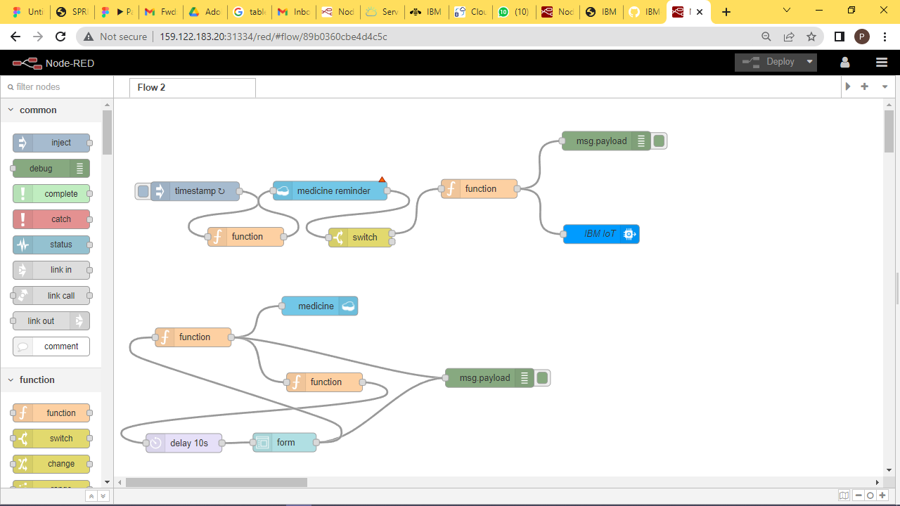

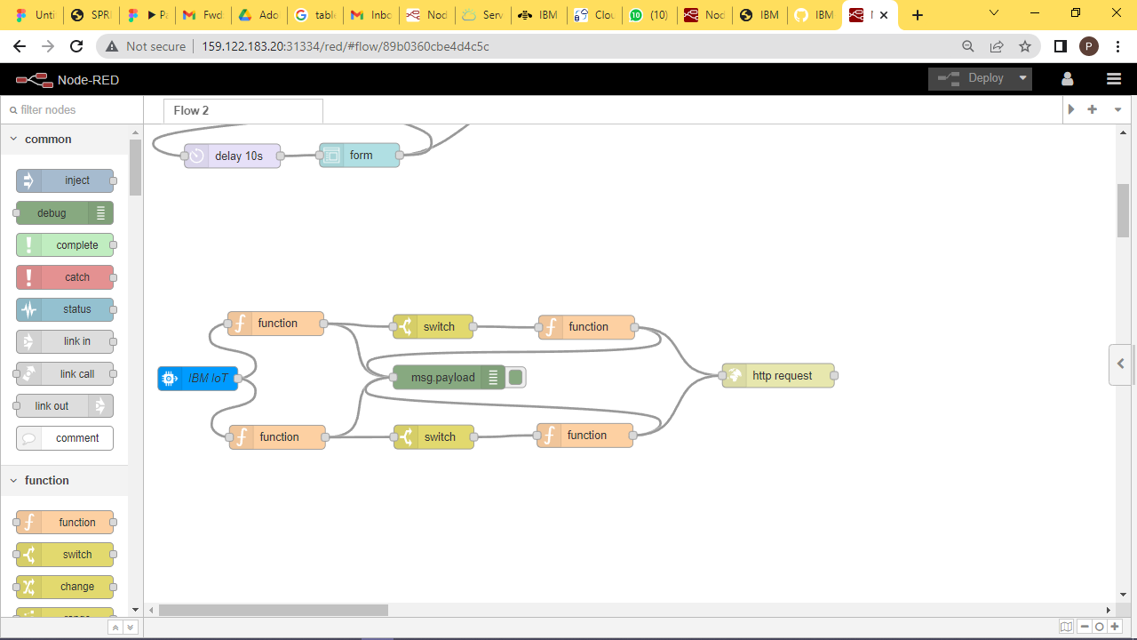

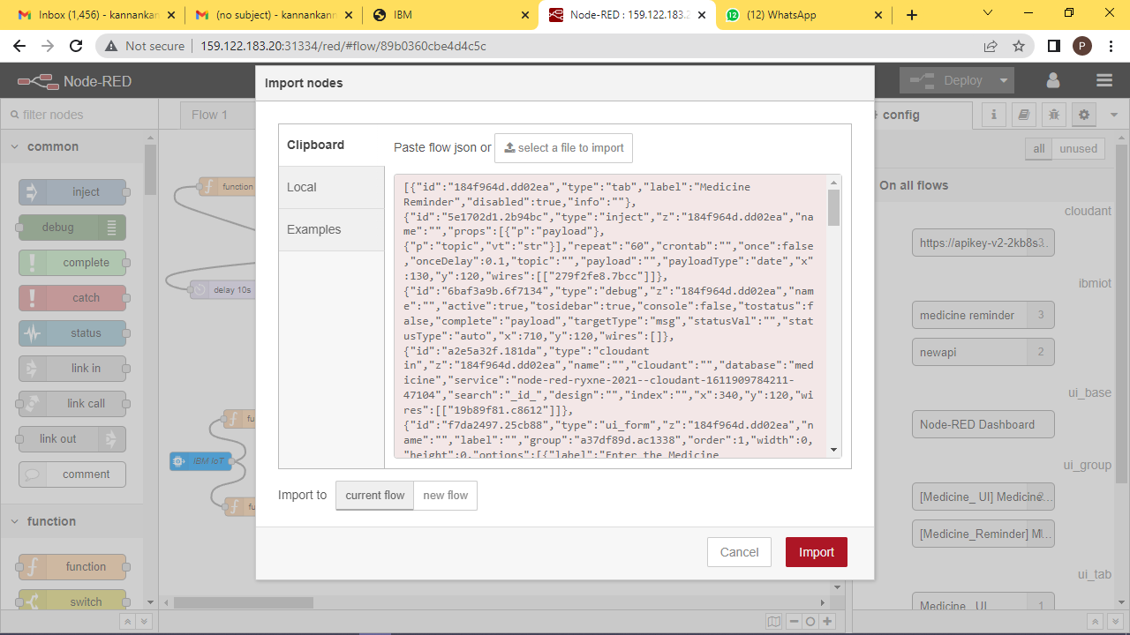

The code has is exported .

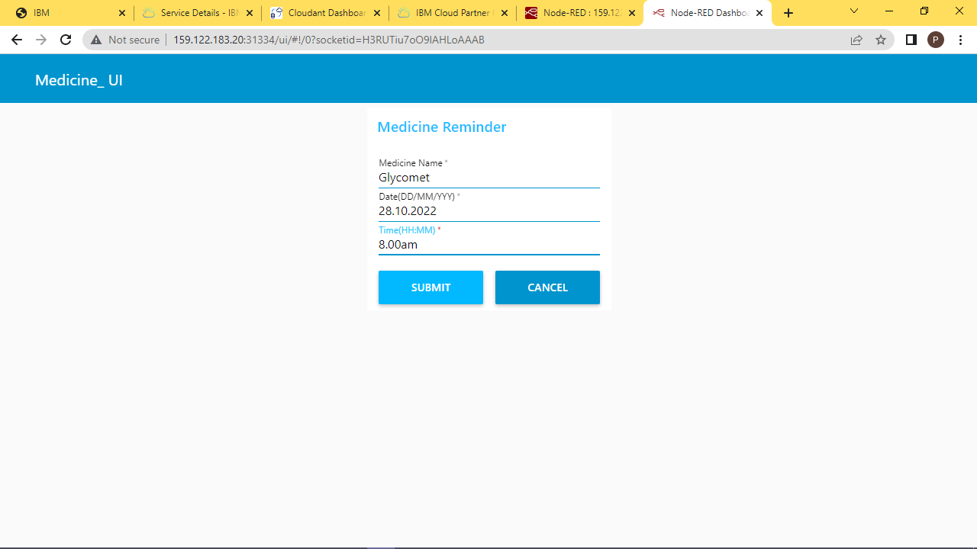

**IBM IOT PLATFORM:**

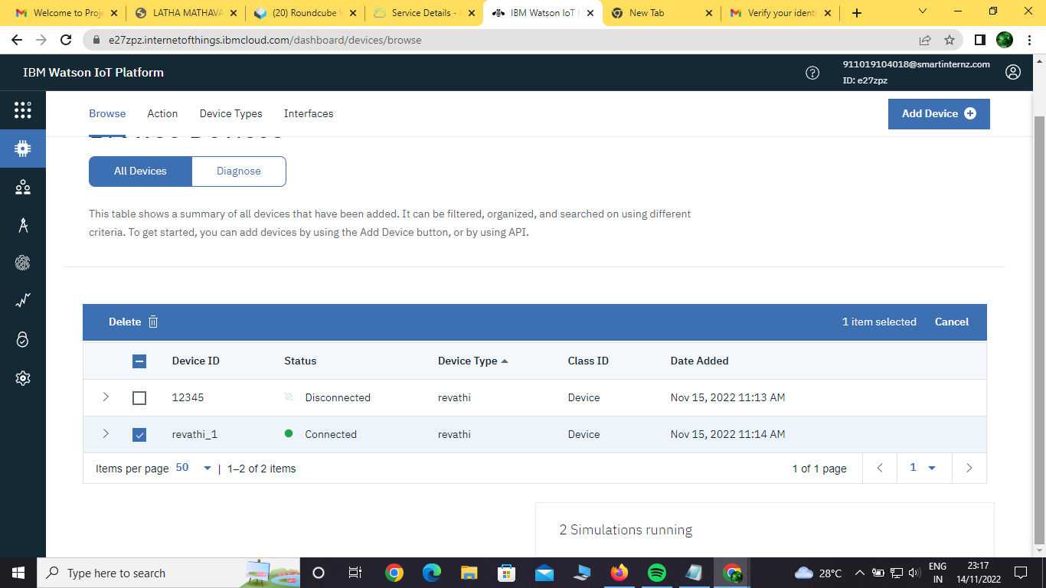

The user details are fetched by IoT device named as “Medreminder”which is created through IBM Watson Platform.

**IBM CLOUDANT DATABASE:**

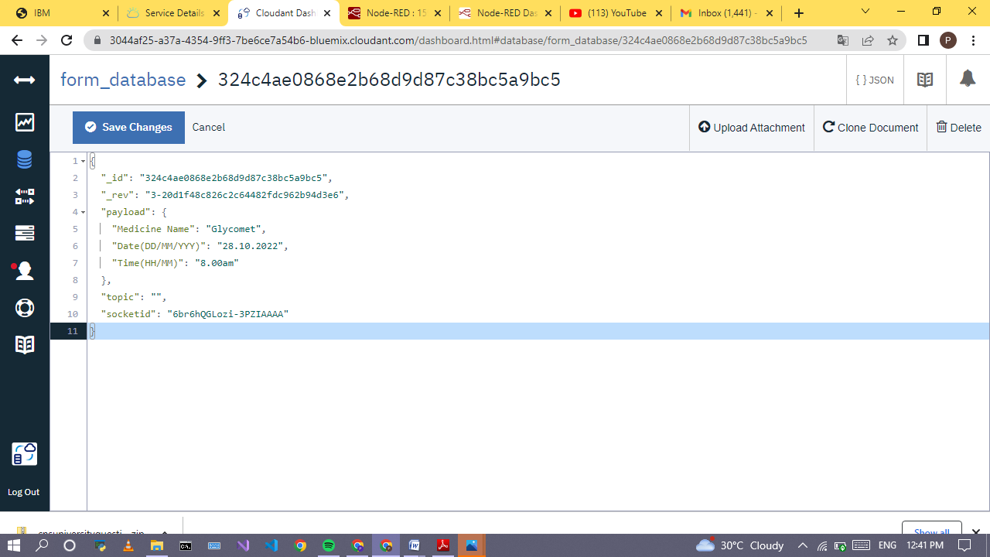

All the medicine details from the user are get stored in IBM Cloudant Database in a JSON Format under the Medreminder database.

**TTS SERVICES:**

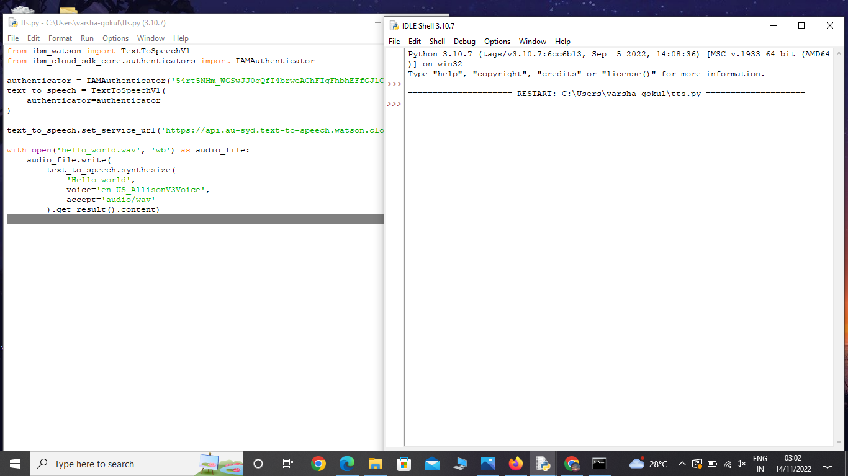

This python file convert the text to speech using IBM TTS service .Using this ,Web application make an alert to the user via voice commands.

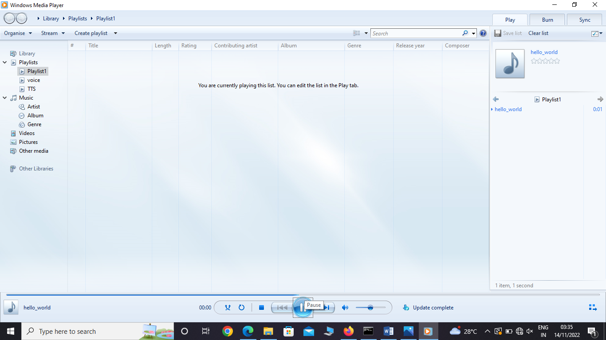

Above screenshot contain the voice command when user get notification about intaking of medicine which is given by the user via web application.

**RESULT:**

Thus, By the end of the sprint-4, the Web UI where user interact with the software is successfully created and tested Successfully.